

# Physical geography Chapter 11: Coral landforms in East Africa

Coral landforms/ reefs are offshore limestone rock platforms formed by continuous deposition and accumulation of shells or skeletons of small marine organisms known as coral polyps.

Polyps are minute living organisms rich in calcium carbonate and when they die; their skeletons get deposited and accumulate on the continental shelf where they are compacted and cemented together to form coral reefs

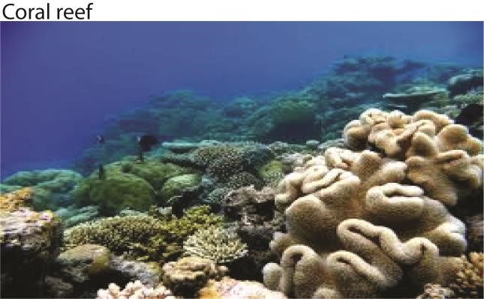

The processes of coral formation therefore involve;

* The death of coral polyps and deposition of skeletons rich in calcium carbonate on the continental shelf
* Over time, the coral deposits increase in weight, become compressed and compacted and cemented together
* In this way, large banks of consolidated rocks are gradually built up, called coral reefs
* The process of cementation and consolidation of coral reefs is facilitated by other organisms such as algae (calcareous algae) and echinoderms.
* The nature of the coral landforms formed depends on the position and shape of the landmass on which they have accumulated. Thus there are three types of coral reefs namely; fringing, barrier and atoll

## Types of coral reefs

The nature of coral landform depends on the position and shape of land mass on which they have accumulated

Fringing reef

* a narrow coral platform of about one kilometer wide joined to the coast or separated from it by a shallow lagoon which may disappear at low water level.
* A fringing reef is formed very close to the coast with its leeward edge sloping steeply into the sea floor.
* Fringing reefs can be seen at the East African coast near Kilifi, Tiwi and Mombassa in Kenya and Oyster Bay at Dar es Salaam in Tanzania.

Barrier reef

* It is a wide coral plat form formed much farther or several kilometers from the coast and separated from it by a much deeper and relatively wider lagoon.
* Barrier reefs can be cited at Mayotte Island between Mozambique and Madagascar

Atoll

* It is a circular shaped coral reef surrounding a wide and fairly deep flat-floored lagoon and generally broken in places by narrow channels.
* Atolls are formed very far from the coast for example Aldabra atoll reef lies 700 km off the coast of East Africa, Chumbe Island found on Zanzibar

## Conditions that favor development of coral reefs

The growth and development of coral landforms along the East African coast is facilitated by;

* Warm temperatures of tropical climate between 200C-300C ideal for growth of coral polyps.

This applies to areas 300N and south of the equator for example Indian Ocean coast

* Availability of salty and well oxygenated seawater with a salinity level of 27- 40 parts per 1000 parts of ocean water provides adequate calcium carbonate taken up from sea water by coral polyps used to build and harden their shells /skeletons.
* Existence of clear, silt free and calm water away from river mouth allows coral growth.
* Existence of shallow continental shelf with depth less than 60 meters allows penetration of sun light to the sea bottom. This enables planktons on which polyps feed to carry out photosynthesis.
* Presence of plentiful supplies of planktons on which polyps feed and survive ▪Presence of solid rock bed along the coast upon which coral reefs grow. A continuous continental shelf along the coast is ideal for the growth of coral reefs.
* Occurrence of sea-level changes/ isostatic adjustments. That is, increase in the sea level encourages coral deposition while a fall in the sea level exposes the coral reefs.
* Presence of calm/ stable water hence no strong waves such as typhoons to destabilize normal growth and accumulation of coral reefs.
* Presence of coral polyps in abundance which when die; deposit skeletons of calcium carbonate which accumulate to form coral landforms.
* The warm Mozambique Ocean current that washes the East African coast helps to maintain the temperatures of the Indian Ocean and thus enables the polyps to survive.

# Theories of coral reef formation

The formation of barrier reefs and atolls has created a lot of controversy as they have been found at far greater depths, in some areas exceeding 1000 meters; a level where polyps cannot survive. As a result, relevant theories have been put forward to explain this anomaly. That is subsidence theory, deglaciation theory and antecedent theory.

## Subsidence theory by Charles Darwin 1842

Charles Darwin explained that the process of coral formation was gradual and occurred due to subsidence of a volcanic island and occurs in three stages

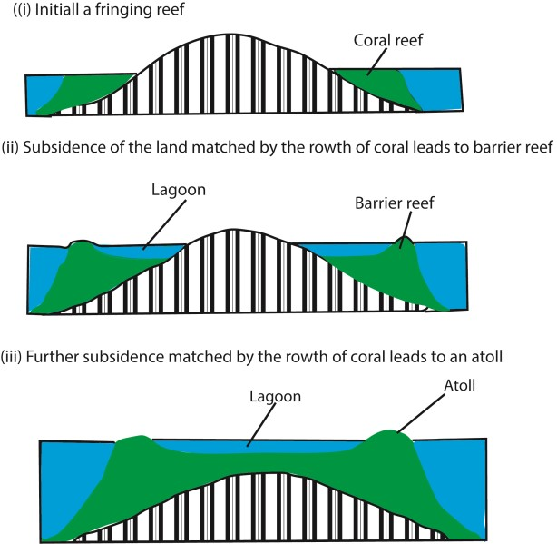

**Stage 1:** Initially corals developed as **fringing reefs** along the coasts of the islands. **Step 2:** The islands subsided downwards due to the down warping of the earth's crust or tectonic movements. To match with the pace of subsidence the corals continued to grow upwards creating a lagoon in between the island and coral reef. The growth was more vigorous at the outer edge so the reef widened leading to the **formation of the Barrier reef.** The water body separating the island from coral is called a lagoon.

**Step 3:** In the 3rd stage further subsidence of the land occurred making it completely submerged below the water level. The corals continued to grow to match the subsidence of land. Now only the outer rim of the reefs was seen **forming an atoll.**

Relevance of the theory to the formation of coral reef landform on East African coast

The theory is relevant because

* there was submergence of the East African coastline evidenced by existence of drowned river valleys called Rias and madflats where Mombasa and Dar-Salaam ports are situated
* there is existence of volcanic islands off the East Africa in Indian Ocean

Weakness of the theory to the formation of coral reef landform on East African coast

* the theory does not explain why some corals are found at great depth of over 1000m where coral polyps cannot survive.
* Some coral polyps have been found in areas where there is no evidence of subermergence.

## Deglaciation theory by Daly

Daly based his theory on the sea level changes during and after the ice age, not subsidence of the volcanic island.

* The sea level was lowered during the cold glacial time
* This led to erosion of all pre-glacial reefs and other islands producing flat and gently sloping platforms.
* Coral polyps colonized these platforms to form fringing reefs.
* When the ice-sheets melted due to deglaciation, there was an increase in the sea level and the fringing reefs continued to grow upwards and outwards thus forming barrier reffs and finally atoll when the hills were completely submerged.
* This transformation took place because the upward and outward growth of corals was able to keep pace with the rate of rice in sea level and maintained growth at the water surface.

Weakness of deglaciation theory of Daly

* Coral reefs have also been found at a great depth denying the assumption that when sea level increases or rises, coral reefs grow to keep pace with increase in the water level.

Comparison between Darwin and Daly’ s coral landform formation

* Darwin believed that initially the submarine platform is stable on which the upward growth of the coral occurs. But once the Fringing reef develops, platform starts to subsidise resulting into the growth of barrier reefs and finally atoll. Daly didn't believe in the role of subsiding platform in the formation of coral reefs. Instead he assumed that coral platform is stable for their entire life-cycle. The structure and time of the formation of coral reef rather depends on the ocean temperature.
* According to Darwin, sea level remains constant during coral reef formation. Daly accepted changes in sea level because of alternate glaciation and melting cycle.
* In Darwin's theory ocean temperature has no role, but Daly attached major importance to the ocean temperature in forming coral reefs. According to him, during ice age, ocean temp went much below killing all existing corals.
* According to Darwin's hypothesis, Fringing reef, Barrier reef and Atoll are the evolutionary stages of growth of coral reefs. So no two of them can exists simultaneously. But Daly didn't believe in such subsequent growth phases and accepted their combined existence which is closer to reality.
* According to Daly coral reefs have formed after Pleistocene Ice age and he didn't believe the atolls and barrier bars of today existed before the glacial period. But no such timeline restriction is accepted in Darwin's theory.
* Both of them accepted the shallow depth of the coral reef adjacent lagoon and it's flat bottom, but they have attributed different reasons for it. According to Darwin, erosion during the crustal subsidence supplied the sediments for deposition. But according to Daly, at the end of ice age when the existing coral died, marine waves eroded the coral reef and atolls and that is the source of sediments.

## Antecedent theory by sir john Murray

According to Murray,

* there existed stable submarine plat forms on which pelagic deposits including corals accumulated at a depth below 60 meters.
* Barrier reefs and atolls began to form on these platforms as fringing reefs.
* As reefs grew upwards and outwards, they were pounded by waves such that masses of coral fragments accumulated on the seaward side; cemented and consolidated into hard reefs .
* The polyps inside the reef however died due to lack of food and their skeletons dissolved in water to form a lagoon inside the reef.
* In this process the fringing reef transformed into barrier reefs and finally into atoll.

Relevancy of Murray’s theory

* Research has established the existence of sediments/pelagic deposits at a depth of 600m on the Bikini Island in line with Murray’s theory
* Atoll have been established to rest on truncated volcanic cones around Aidabara as was suggested by Murray
* There are pronounced coral polyps growth on the seaward side the inland side
* Fragments of corals do exist in lagoons between reefs which suggest that at one time the whole part was made of corals that later died due to limited food supply.
* The steepness of the coral reefs is greater in the seaward side than on the land side which is in line with Murray’s suggestion that coral fragments accumulated on the seaward side

Weakness of Murray’s theory

* Coral reefs are very hard and not easily worn down as Murray had suggested
* The lagoons formed by barrier reefs and atoll are so deep and wide that it’s unlikely that were formed by dissolution of the corals which lacked food as suggested by Murray.

-

Relevance of Mrray’s theoty

## Economic importance of coral reefs Positive of coral reef landforms

* Coral reefs are tourist attractions because of their beautiful shapes and color which make them unique hence a source of foreign exchange for Kenya and Tanzania. For example fringing reefs at Bamburi, Shungyu in Dar es Salaam.
* Coral reefs contain limestone which is extracted for production of cement used in construction works for example Bamburi cement.
* Coral reefs are source of education material and research. For example in the field of oceanography, geomorphology and search for oil prospects.
* Coral reefs weather down into fertile soils which support crop cultivation for example coconuts, mangoes, citrus fruits and cashew nuts and cloves in Pemba, Mombasa and Zanzibar.
* Coral reefs contain limestone used in manufacturing fertilizers rich in calcium carbonates hence boosts crop cultivation.
* Fringing reefs have favored the development of ports by protecting the harbor from destructive waves which would otherwise have destroyed the coast through flooding. For example port Mombasa and Dar es Salaam.
* Fringing reefs also protect beach swimmers from dangerous marine organisms such as crocodiles and hippos because they find it difficult to cross the reefs to the beach. This promotes tourism.
* Coral reefs are potential areas for mining oil because they contain a lot of fats which sip down and accumulate into rock strata to form oil wells.
* Fishing is carried out in the coral lagoons. For example fish, crabs and lobsters
* Lagoons are also used for recreation purposes such as swimming and sun bathing especially tourists.
* Some corals are precious e.g. this with a hard core are used by craft men to curve out jewelry materials.

-

## Negative effects of coral reef landforms

* Coral reefs weather down into poor sandy soils which discourage growing of other crops apart from coconut and cloves.
* Fringing and barrier reefs are obstacles to marine transport and fishing because they form hard projecting rocks which wreck ships, fishing boats and nets.
* Coral lagoons are colonized by mangrove vegetation during the low tides leading to spread of disease vectors such as mosquitoes which cause malaria.
* Fringing reefs limit the size of docking area at Mombasa and Dar es Salaam Ports which results into congestion of ships and limited space for ocean wagons
* The sharp reefs also tear fishing nets and may interfere with the fishing**.**

Revision questions

1. Account for the formation of coral landforms in East Africa Approach

(Define clearly coral landforms; Describe the process of formation; Identify the types; Explain conditions which favor their formation in East Africa; Explain the theories put forward to explain the formation of coral landforms)

1. Assess the relevance of the Darwin’s theory to the understanding of the formation of coral landforms in East Africa.

(define coral land forms; identify types of corals and show their distribution in E.A.; show conditions favoring coral reef formation; explain the formation of corals with reference to Darwin’s theory; assess the relevance of Darwin’s theory giving strength and weakness.

3.

Thank you Dr. Bbosa Science